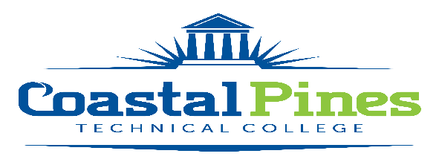

POSITION: Federal College Work Study (FCWS) Reading Tutor

DEPARTMENT: Student Affairs

STATUS: Part-time/Non-exempt LOCATION: All Campuses

Education and/or Occupational Experience:
Possess a high school diploma, a GED, pass an approved ability to benefit test, or have been home-schooled. Also, FCWS student must be enrolled as a student and taking at least six credit hours at Coastal Pines Technical College in a technical certificate of credit, diploma, or associate degree program.
Minimum Qualifications:
- Be a United States citizen, permanent resident, or other reliable classification of non-citizen
- Have a valid Social Security number
- Make Satisfactory Academic Progress for Federal Student Aid Programs
- Meet the requirements of the Federal College Work Study Program
Key Competencies
- Excellent verbal communication skills and customer service skills
- Reading Skills
- Ability to work in a Library Setting with Children
- Ability to tutor Children or Families in reading
- Ability to maintain and update filing system

Duties/Responsibilities
Federal College Work Study Students may work up to but no more than 20 hours per week.
This FCWS worker will be responsible for the following:

- Working at Libraries or Community Centers as a Reading Tutor
- Conducting tutoring/reading sessions to Families and Children
- Working as a team member in a library
- Providing Customer service Internally and Externally
- Performing other duties as directed by immediate supervisor
- Applicant will serve as reading tutor for local community

APPLICATION DEADLINE:
Open until filled.

SALARY:
$10.00/hour

APPLICATION PROCEDURE:
Interested applicants should apply via CPTC’s Online Job Center at CPTC Online Job Center. A cover letter with resume, two professional letters of recommendation and copies of transcript(s)/license(s)/certification(s) must be uploaded with the application. A criminal background check and a driver’s motor history report will be conducted prior to employment. Official transcripts are required upon hire.

For additional information, contact Katrina Howard, Human Resources Director at mailto:khoward@coastalpines.edu, or 912-427-5876.

Coastal Pines Technical College (CPTC) does not discriminate on the basis of race, color, creed, national or ethnic origin, gender, religion, disability, age, political affiliation or belief, genetic information, veteran status, or citizenship status (except in those special circumstances permitted or mandated by law). The following persons have been designated to coordinate the College’s implementation of non-discrimination policies: Katrina Howard, Title IX Coordinator, Jesup Campus, 1777 West Cherry Street, Jesup, Georgia, khoward@coastalpines.edu , 912.427.5876; Brittaney Coleman, Title IX Coordinator, Waycross Campus, 1701 Carswell Avenue, Waycross, Georgia, bcoleman@coastalpines.edu, 912.287.4098; Cathy Montgomery, ADA/Section 504 Coordinator, All Campuses, 3700 Glynco Pkwy., Brunswick, Georgia, cmontgomery@coastalpines.edu, 912.262.9995.

EEO/AA Coordinator
Brittaney Coleman, HR Coordinator
1701 Carswell Avenue
Waycross, GA 31503
(912)287-4098
bcoleman@coastalpines.edu

EEO/AA Coordinator
Katrina Howard, HR Director
1777 W. Cherry Street
Jesup, GA 31545
(912) 427-5876
khoward@coastalpines.edu

