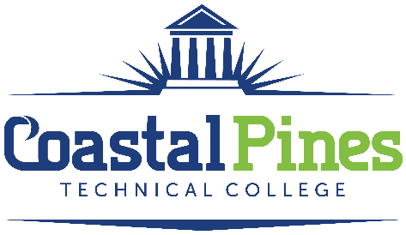

POSITION: STATUS: Part Time/Non-Exempt
Criminal Justice Instructor - Adjunct

SALARY:
Salary is commensurate with experience. This is an adjunct position with no benefits.

DUTIES:
Successful applicants will be responsible for overall classroom instruction for degree level courses to include: preparing lesson plans, maintaining department guidelines and standards, evaluating students by assigning grades and interact with other faculty and deans.
MINIMUM QUALIFICATIONS:
- A minimum of a master’s degree in Criminal Justice or a master’s degree with 18+ graduate semester hours in Criminal Justice from an accredited institution.
- Excellent written and verbal communication skills.
PREFERRED QUALIFICATIONS:
- Teaching experience in secondary and/or postsecondary educational institution.

Application Process:
Interested applicants should apply via CPTC ONLINE JOB CENTER by completing the online application form. The letter of interest and resume along with copies of high school diploma or transcripts must be uploaded to the Job Center. Incomplete application packages will not be considered. A criminal background check and a driver’s motor history report will be conducted prior to employment.

For additional information, contact Katrina Howard, Human Resources Director at khoward@coastalpines.edu, or call 912-427-5876.

Coastal Pines Technical College (CPTC) does not discriminate on the basis of race, color, creed, national or ethnic origin, gender, religion, disability, age, political affiliation or belief, genetic information, veteran status, or citizenship status (except in those special circumstances permitted or mandated by law). The following persons have been designated to coordinate the College’s implementation of non-discrimination policies: Katrina Howard, Title IX Coordinator, Jesup Campus, 1777 West Cherry Street, Jesup, Georgia, khoward@coastalpines.edu , 912.427.5876; Brittaney Coleman, Title IX Coordinator, Waycross Campus, 1701 Carswell Avenue, Waycross, Georgia, bcoleman@coastalpines.edu, 912.287.4098; Cathy Montgomery, ADA/Section 504 Coordinator, All Campuses, 3700 Glynco Parkway, Brunswick, GA 31525, cmontgomery@coastalpines.edu, 912.262.9995.

