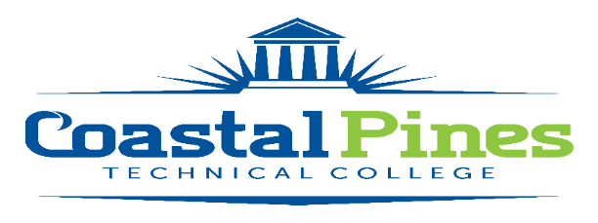

Position Announcement

Accounting Technician

**Position:** Bookstore Assistant **Status:** Full time/non-exempt

32 hours/week

**Location:** Camden Campus

**Qualifications:**

High School diploma or equivalent *and* one (1) year of related work experience

**Responsibilities:**

The Bookstore Assistant will perform a variety of duties to include:

1. Performs the cashiering function for the College store to include entering data into Win Prism point of sale system and for the College by entering student data into the Banner Accounts Receivable system.
2. Ordering, receiving, pricing, stocking and returning textbooks, supplies and other merchandise.
3. Performs the receiving function for College deliveries.
4. Assists the College Store Manager with bookstore inventories as scheduled and other activities related to the bookstore.
5. Schedules the College’s vehicles for use by employees.
6. Coordinates routine maintenance/cleaning and vehicle maintenance records of the College’s vehicles.
7. Maintains and reconciles the purchasing card for the Camden College Store.
8. Assists other members of Administrative Services department with various projects and activities; perform other activities as assigned.
9. Participates in required staff development activities.
10. Performs other duties as assigned by the College Store Manager.

The bookstore assistant will be required to work with employees of Coastal Pines Technical College, as well as, the public in a professional and courteous manner and will be required to maintain the confidentiality of information.

**Application Deadline:**

Position open until filled. The interview process will begin immediately.

**Salary/Benefits:**

$29,000 annually. Salary will be determined in accordance with guidelines established by the Technical College System of Georgia. Benefits include the State of Georgia Flexible Benefits Program, State of Georgia holidays, and annual/sick leave.

To be considered for this position, submit a resume, letter of interest, and online employment application on our Job Opportunities website www.coastalpines.edu. Official transcripts must be on file prior to interviews. Applicants must state in the letter of interest the position for which they are applying. Incomplete applications will not be considered. Final candidate will be required to successfully meet the requirements of the TCSG Background Investigation Policy.

Coastal Pines Technical College (CPTC) does not discriminate on the basis of race, color, creed, national or ethnic origin, gender, religion, disability, age, political affiliation or belief, genetic information, veteran status, or citizenship status (except in those special circumstances permitted or mandated by law). The following persons have been designated to coordinate the College’s implementation of non-discrimination policies: Katrina Howard, Title IX Coordinator, Jesup Campus, 1777 West Cherry Street, Jesup, Georgia, [khoward@coastalpines.edu](mailto:khoward@coastalpines.edu) , 912.427.5876; Brittaney Coleman, Title IX Coordinator, Waycross Campus, 1701 Carswell Avenue, Waycross, Georgia, [bcoleman@coastalpines.edu](mailto:bcoleman@coastalpines.edu), 912.287.4098; Cathy Montgomery, ADA/Section 504 Coordinator & Title IX Coordinator for all students, All Campuses, 3700 Glynco Parkway, Brunswick, GA, 31525, [cmontgomery@coastalpines.edu](mailto:cmontgomery@coastalpines.edu), 912.262.9995.