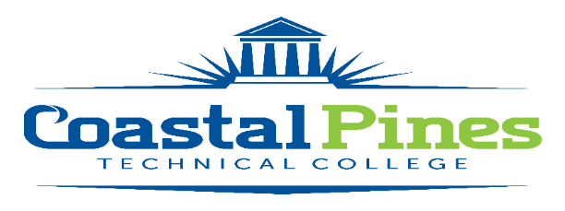

Position Announcement

Accounting Technician

**Position:** Bookstore Assistant **Status:** Full time/non-exempt (32hours/week)

**Location:** Waycross Campus

**Qualifications:**

High School diploma or equivalent *and* one (1) year of related work experience

**Responsibilities:**

The Bookstore Assistant will perform a variety of duties to include:

1. Performs the cashiering function for the College store to include entering data into Win Prism point of sale system and for the College by entering student data into the Banner Accounts Receivable system.
2. Ordering, receiving, pricing, stocking and returning textbooks, supplies and other merchandise.
3. Performs the receiving function for College deliveries.
4. Assists the College Store Manager with bookstore inventories as scheduled and other activities related to the bookstore.
5. Schedules the College’s vehicles for use by employees.
6. Coordinates routine maintenance/cleaning and vehicle maintenance records of the College’s vehicles.
7. Maintains and reconciles the purchasing card for the Camden College Store.
8. Assists other members of Administrative Services department with various projects and activities; perform other activities as assigned.
9. Participates in required staff development activities.
10. Performs other duties as assigned by the College Store Manager.

The bookstore assistant will be required to work with employees of Coastal Pines Technical College, as well as, the public in a professional and courteous manner and will be required to maintain the confidentiality of information.

**Salary/Benefits:**

Salary will be determined in accordance with guidelines established by the Technical College System of Georgia. Benefits include the State of Georgia Flexible Benefits Program, State of Georgia holidays, and annual/sick leave.

**Application Process:**

Interested applicants should apply via [CPTC ONLINE JOB CENTER](https://apps.bluefinhr.com/JC_CoastalPines/joblistings/joblistings.aspx) by completing the online application form. The letter of interest and resume along with additional documentation specific to the position must uploaded to the Job Center. Incomplete application packages cannot be considered for an interview and will not be forwarded to the hiring supervisor. A criminal background check and a driver’s motor history report will be conducted prior to employment.

**Equal Opportunity Statement**

Coastal Pines Technical College (CPTC) does not discriminate on the basis of race, color, creed, national or ethnic origin, gender, religion, disability, age, political affiliation or belief, genetic information, veteran status, or citizenship status (except in those special circumstances permitted or mandated by law). The following persons have been designated to coordinate the College’s implementation of non-discrimination policies: Katrina Howard, Title IX Coordinator, Jesup Campus, 1777 West Cherry Street, Jesup, Georgia, [khoward@coastalpines.edu](mailto:khoward@coastalpines.edu) , 912.427.5876; Emily Harris, Title IX Coordinator, Waycross Campus, 1701 Carswell Avenue, Waycross, Georgia, [eharris@coastalpines.edu](mailto:eharris@coastalpines.edu), 912-287-4098; [titleix@coastalpines.edu](mailto:titleix@coastalpines.edu) ADA/Section 504 Coordinator, ada@coastalpines.edu ; All Campuses, 1777 West Cherry Street, Jesup, Georgia.