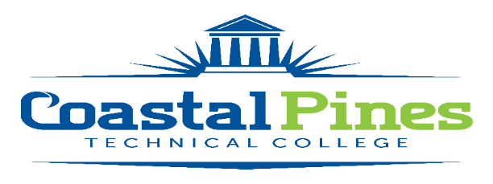
Library Services Director

POSITION: Status: Fulltime/Exempt
The Library Services Director is responsible for planning, organizing and directing the overall administration of the college’s library system.

DUTIES:

- Directs and coordinates a comprehensive library program, which may include a media center, at a single or multi-campus technical college
- Develops library and information resource goals and objectives
- Provides library instruction to students in classes and one-on-one
- Plans, organizes and supervises the unit's work to support instruction and meet the technical college's objectives. Directs and reviews work assignments
- Selects, orders, processes and maintains up-to date library resource collections; Manages reference checks for all campuses
- Prepares and submits various internal and external narrative and statistical reports and disseminates information
- Responsible for providing input into and executing library resource functions of supporting distance education and on-line instruction
- Represents the technical college on matters concerning libraries, and when appropriate, instructional media and emerging instructional technologies
- Manages and oversees financial/budget operations of the department
- Monitors the activities of personnel to ensure compliance with TCSG policy manual and department procedures
- Develops and/or assists with the development of policies and procedures and recommends changes to effectively meet the goals and requirements of the program
- Evaluates employees at scheduled intervals upon reviewing of all relevant information
- Conducts regular evaluation of services provided and make adjustments as needed
- Maintains up-to-date policies, procedures, and state or federal laws that may impact department initiatives.

EDUCATION:
Master of Library Science degree from an American Library Association (ALA) accredited institution *and* Two (2) years of experience as a Librarian.
PREFERRED QUALIFICATIONS:
Previous academic library experience and supervisory experience.

APPLICATION DEADLINE:
Open until filled

SALARY/BENEFITS:
Salary will be determined in accordance with guidelines established by the Technical College System of Georgia. Benefits include the State of Georgia Flexible Benefits Program, State of Georgia holidays, and annual/sick leave.

APPLICATION PROCESS:
To be considered for this position, submit a resume, cover letter, transcripts and an online employment application on our Job Opportunities Careers website www.coastalpines.edu . Official transcripts must be on file within 30 days of hire. Applicants must state in the cover letter the position for which they are applying. Incomplete applications will not be considered. Final candidate will be required to successfully meet the requirements of the TCSG Background Investigation Policy.

Coastal Pines Technical College (CPTC) does not discriminate on the basis of race, color, creed, national or ethnic origin, gender, religion, disability, age, political affiliation or belief, genetic information, veteran status, or citizenship status (except in those special circumstances permitted or mandated by law). The following persons have been designated to coordinate the College’s implementation of non-discrimination policies: Katrina Howard, Title IX Coordinator, Jesup Campus, 1777 West Cherry Street, Jesup, Georgia, khoward@coastalpines.edu , 912.427.5876; Brittaney Coleman, Title IX Coordinator, Waycross Campus, 1701 Carswell Avenue, Waycross, Georgia, bcoleman@coastalpines.edu, 912.287.4098; Katie Rutland, ADA/Section 504 Coordinator and Title IX Coordinator for all students, all campuses, 1777 West Cherry Street, Jesup, Georgia, krutland@coastalpines.edu, 912.427.1527.

