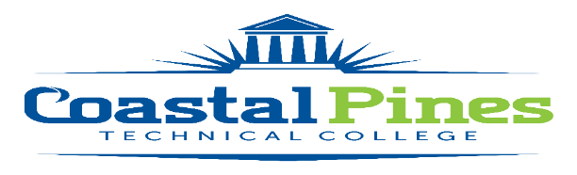

Position: Allied Health Instructor Pool Status: Part-time/Exempt

Job Location: All

Job Description:
Successful applicants will be responsible for overall classroom instruction for certificate level General Allied health Core courses to include: preparing lesson plans, maintaining department guidelines and standards, evaluating students by assigning grades and interact with other faculty and deans.

Job Duties and Responsibilities:
- Assist in development and implementation of the curriculum for the associated diploma and/or certificate programs.
- Recommend purchase of instructional equipment and supplies for initial set-up and subsequent program growth; design classroom and laboratory space.
- Specific teaching responsibilities:
  - use appropriate teaching, testing, and grading techniques;
  - demonstrate current knowledge of subject area;
  - use effective written and oral communication skills;
  - maintain educational records;
  - assist in developing curriculum; selecting textbooks and supplementary instructional materials;
  - use technology appropriate to the subject taught;
  - establish course and program learning outcomes and evaluate students’ progress in attaining goals and objectives;
  - order supplies and equipment;
  - assist with student recruitment, retention, advisement, and placement; and
  - adhere to accreditation requirements for the program and the College.
- Maintain qualifications for employment as required by Technical College System of Georgia (TCSG) and the College.
- Adhere to the rules and regulations stated in the Policy Manual and to the policies and procedures of the college.
- Serve on committees as assigned.
- Participate in division and college-wide meetings as appropriate.
- Participate in the college’s faculty development program.
- Perform other duties as assigned.
MINIMUM QUALIFICATIONS:
- A minimum of an Associate’s degree in the teaching discipline from an accredited institution.
- Professional in-field certification/licensures
- In-field work experience within the past seven years.
- Excellent written and verbal communication skills.

PREFERRED QUALIFICATIONS
- Teaching experience in secondary and/or postsecondary educational institution.

APPLICATION DEADLINE:
Positions are filled on an as needed basis.

Salary:
$23/per hour Salary is in accordance with guidelines established by the Technical College System of Georgia.

Additional Information: This is a professional position in higher education, exempt from the Fair Labor Standards Act (FLSA).

APPLICATION PROCESS:
Interested applicants should apply via CPTC ONLINE JOB CENTER by completing the online application form. The letter of interest, certifications/licensures and resume along with copies of transcripts must be uploaded to the Job Center. A criminal background check and a driver’s motor history report will be conducted prior to employment. Official transcripts are required upon hire.

For additional information, contact Cynthia Linder, Human Resources Director at clinder@coastalpines.edu, or call 912-287-4098.

Coastal Pines Technical College (CPTC) does not discriminate on the basis of race, color, creed, national or ethnic origin, gender, religion, disability, age, political affiliation or belief, genetic information, veteran status, or citizenship status (except in those special circumstances permitted or mandated by law). The following persons have been designated to coordinate the College’s implementation of non-discrimination policies: Katrina Howard, Title IX Coordinator, Jesup Campus, 1777 West Cherry Street, Jesup, Georgia, khoward@coastalpines.edu , 912.427.5876; Cynthia Linder, Title IX Coordinator, Waycross Campus, 1701 Carswell Avenue, Waycross, Georgia, clinder@coastalpines.edu, 912.287.4098; Cathy Montgomery, ADA/Section 504 Coordinator, All Campuses, 3700 Glynco Parkway, Brunswick, Georgia, cmontgomery@coastalpines.edu, 912.262.9995.

