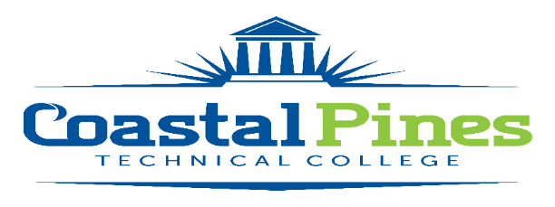

Full-time Custodian

Division: Facilities Status: Fulltime/Non-Exempt
Campus Location: Brunswick

Minimum Qualifications:
High School Diploma or GED Equivalent.

Preferred Qualifications:
A minimum of three year’s work experiences performing custodial duties, to include the proper safety and use of chemicals.

Competencies:
Knowledge of custodial tools and methods
Knowledge of safety guidelines
Skill in the use of cleaning tools and supplies
Proper use of chemicals & other cleaning liquids
Ability to read and follow instructions
Ability to lift up to 40 pounds regularly
Ability to bend, squat, reach, crawl and climb ladder

Responsibilities:

Under general supervision, maintains proper care of Coastal Pines Technical College facilities. Performs a variety of routine duties such as cleaning, moving furniture, removing trash, stripping and waxing, etc. Maintains appropriate materials, tools and equipment. Adheres to State of Georgia policies and Coastal Pines Technical College procedures.

The Custodian will perform a variety of duties to include:

- Cleans facilities, including blinds, windows, light fixtures, drinking fountains and walls.

- Vacuums, sweeps, mops, scrubs, strips, waxes and cleans floors.

- Empties all trash daily.

- Thoroughly cleans restrooms and keeps stocked with paper products and soap.

- Cleans windows and doors and keeps entrances clean and free of debris.

- Selects appropriate tools, materials, and equipment for each task.

- Maintains equipment and reports lost, damaged, or broken tools or equipment to the Executive Director of Facilities.

- Adheres to all safety rules and guidelines set by the College.

- Demonstrates eagerness to learn and assume responsibility; seeks out and accepts increased responsibility.

- Works within the system in a resourceful manner to accomplish reasonable work goals; shows flexibility in response to process change and adapts to and accommodates new methods and procedures.

- Accepts direction and feedback from supervisor and follows through appropriately.

- Works when scheduled; begins and ends work as expected; calls in according to policy when arriving late for work or when absent; observes provisions of Fair Labor Standards Act; observes policies on break and lunch periods.

- Assists with duties outside of assigned areas when other custodians are out.

- Participates in required staff development activities.

- Performs other duties as assigned by the Maintenance Supervisor or Executive Director of Facilities.

The Custodian will be required to work with employees of Coastal Pines Technical College, as well as, the public in a professional and courteous manner and will be required to maintain the confidentiality of information.

Application Deadline:
Open until filled.

Salary/Benefits:
Salary will be determined in accordance with guidelines established by the Technical College System of Georgia. This is a full-time position with a State of Georgia benefits package.

To be considered for this position, submit a resume, and an online employment application on our Job Opportunities website www.coastalpines.edu. Applicants must state in the letter of interest the position for which they are applying. Incomplete applications will not be considered. Final candidate will be required to successfully complete a criminal background check and a driver’s motor history report prior to employment.

Coastal Pines Technical College (CPTC) does not discriminate on the basis of race, color, creed, national or ethnic origin, gender, religion, disability, age, political affiliation or belief, genetic information, veteran status, or citizenship status (except in those special circumstances permitted or mandated by law). The following persons have been designated to coordinate the College’s implementation of non-discrimination policies: Katrina Howard, Title IX Coordinator, Jesup Campus, 1777 West Cherry Street, Jesup, Georgia, khoward@coastalpines.edu , 912.427.5876; Brittaney Coleman, Title IX Coordinator, Waycross Campus, 1701 Carswell Avenue, Waycross, Georgia, bcoleman@coastalpines.edu, 912.287.4098; Cathy Montgomery, ADA/Section 504 Coordinator, All Campuses, 1777 West Cherry Street, Jesup, Georgia, cmontgomery@coastalpines.edu, 912.427.6265.

