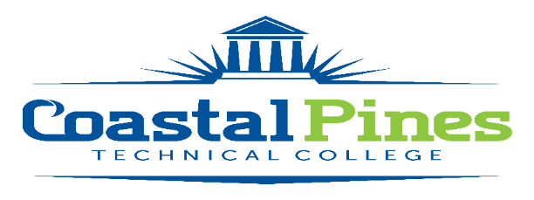

Custodian

Division: Facilities Status: Full-time/non-exempt
Campus Location: Camden

Minimum Qualifications:
High School Diploma or GED Equivalent.

Preferred Qualifications:
A minimum of three year’s work experiences performing custodial duties, to include the proper safety and use of chemicals.

Competencies:
Knowledge of custodial tools and methods
Knowledge of safety guidelines
Skill in the use of cleaning tools and supplies
Proper use of chemicals & other cleaning liquids
Ability to read and follow instructions
Ability to lift up to 40 pounds regularly
Ability to work outside in extreme weather conditions
Ability to bend, squat, reach, crawl and climb ladder

Responsibilities:
The custodian will perform a variety of duties to include:
- Maintains proper care of technical college facilities;
- Provides care and routine maintenance of grounds;
- Clears storm drains and traps of debris;
- Performs a variety of duties related to the job, such as painting, replacing light bulbs, hanging curtains, moving furniture, setting up chairs, tables, lights and podiums for special events and college functions;
- Distributes and maintains materials, tools and equipment;
- Cleaning, mopping, sweeping and vacuuming offices and bathrooms;
- Stock bathrooms with tissue, hand towels and soap;
- Assembles office equipment and desks;
- Assesses campus grounds for maintenance needs;
- Mows grass and trims weeds;
- Places pine straw; mulches beds around trees and buildings;
- Collects trash and debris for disposal;
- Pushing, pulling and lifting 50lb objects
- Assists personnel in the arrangement of desks and other office equipment.
- Other duties as assigned by supervisor

The Custodian will be required to work with employees of Coastal Pines Technical College, as well as, the public in a professional and courteous manner and will be required to maintain the confidentiality of information.

Application Deadline:
Open until filled.

Salary/Benefits:
TBD. Benefits include the State of Georgia Flexible Benefits Program, State of Georgia holidays, and annual/sick leave.

To be considered for this position, submit a complete online employment application on our Job Opportunities website www.coastalpines.edu. Incomplete applications will not be considered. Final candidate will be required to successfully complete a criminal background check and a driver’s motor history report prior to employment.
For additional information, contact Katrina Howard, Human Resources Director at khoward@coastalpines.edu or call 912-427-5876.

Coastal Pines Technical College (CPTC) does not discriminate on the basis of race, color, creed, national or ethnic origin, gender, religion, disability, age, political affiliation or belief, genetic information, veteran status, or citizenship status (except in those special circumstances permitted or mandated by law). The following persons have been designated to coordinate the College’s implementation of non-discrimination policies: Katrina Howard, Title IX Coordinator, Jesup Campus, 1777 West Cherry Street, Jesup, Georgia, khoward@coastalpines.edu , 912.427.5876; Cynthia Linder, Title IX Coordinator, Waycross Campus, 1701 Carswell Avenue, Waycross, Georgia, bcoleman@coastalpines.edu, 912.287.4098; Cathy Montgomery, ADA/Section 504 Coordinator, All Campuses, 3700 Glynco Parkway, Brunswick, GA 31525, cmontgomery@coastalpines.edu, 912.262.9995.

