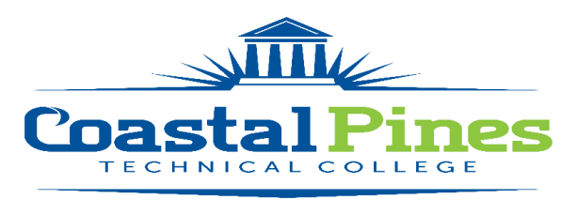

POSITION: STATUS: Full-time/Exempt
Electrical Line worker Instructor

SALARY:
TBD. This is a full-time position with a State of Georgia benefits package.

DUTIES:
Successful applicants will be responsible for overall classroom and field experience instruction for certificate level courses in the Electrical Line worker Program including preparing lesson plans, maintaining department guidelines and standards, evaluating students by assigning grades and interacting with staff, faculty, and deans. Primary appointment is Waycross Campus. Position begins August 1, 2022.

MINIMUM QUALIFICATIONS:
- Diploma with completed courses comparable with program curriculum – OR-
- · Completed courses with comparable curriculum.
- · 3 years’ experience in the field of Electrical Linework.
- · Documented experience in curriculum taught.
- · Valid Georgia Commercial Driver’s License.
- · Excellent written and verbal communication skills.

PREFERRED QUALIFICATIONS:
- Teaching experience in secondary and/or postsecondary educational institution.

APPLICATION DEADLINE:
Open until filled. Initial screening/interviewing will begin as needed.

APPLICATION PROCEDURE:
Interested applicants should apply via CPTC’s Online Job Center. A cover letter with resume, two professional letters of recommendation and copies of transcript(s)/license(s)/certification(s) must be uploaded with the application. A criminal background check, drug & alcohol screening and a motor vehicle report will be conducted prior to employment. Official transcripts are required upon hire.

For additional information, contact Katrina Howard, Human Resources Director at khoward@coastalpines.edu , or (912) 427-5876.

Coastal Pines Technical College (CPTC) does not discriminate based on race, color, creed, national or ethnic origin, gender, religion, disability, age, political affiliation or belief, genetic information, veteran status, or citizenship status (except in those exceptional circumstances permitted or mandated by law). The following persons have been designated to coordinate the College’s implementation of non-discrimination policies: Katrina Howard, Title IX Coordinator, Jesup Campus, 1777 West Cherry Street, Jesup, Georgia, khoward@coastalpines.edu , 912.427.5876; Brittaney Coleman, Title IX Coordinator, Waycross Campus, 1701 Carswell Avenue, Waycross, Georgia, bcoleman@coastalpines.edu, 912.287.4098; Katie Rutland, ADA/Section 504 Coordinator and Title IX for all students, all campuses, 1777 W. Cherry Street, Jesup, Georgia, 31545, krutland@coastalpines.edu , 912.427.1527.

