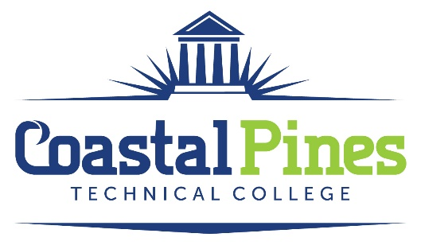

Position: Status:
Federal College Work Study Program Part-time/Non-exempt

Education and/or Occupational Experience:
Possess a high school diploma, a GED, pass an approved ability to benefit test, or have been home-schooled. Also, FCWS student must be enrolled as a student and taking at least six credit hours at Coastal Pines Technical College in a technical certificate of credit, diploma, or associate degree program.
Minimum Qualifications:
- Be a United States citizen, permanent resident, or other reliable classification of non-citizen
- Have a valid Social Security number
- Make Satisfactory Academic Progress for Federal Student Aid Programs
- Meet the requirements of the Federal College Work Study Program
Key Competencies:
- Excellent verbal communication skills and customer service skills
- Computer skills
- Data Entry skills – Both alpha and numeric
- Ability to maintain records
- Ability to maintain and update filing system
- Preferred that applicant has completed Comp 1000

Application Deadline: Salary:
Open until filled. $15.00/hour

Length of Employment: Work study employment will end on the final day of the semester.
Federal College Work Study Students may work up to but no more than 19 hours per week.
Once approved through Financial Aid, applicant will work with Abigail Davis, Career Services Coordinator, to discuss start date and work location.

Application Process:
Interested applicants should apply via CPTC ONLINE JOB CENTER. The additional documents must be uploaded to the Job Center for the application to be considered. Once approved through financial aid, a criminal background check and a driver’s motor history report will be conducted prior to employment.

Equal Opportunity Statement
Coastal Pines Technical College (CPTC) does not discriminate on the basis of race, color, creed, national or ethnic origin, gender, religion, disability, age, political affiliation or belief, genetic information, veteran status, or citizenship status (except in those special circumstances permitted or mandated by law). The following persons have been designated to coordinate the College’s implementation of non-discrimination policies: Katrina Howard, Title IX Coordinator, Jesup Campus, 1777 West Cherry Street, Jesup, Georgia, khoward@coastalpines.edu , 912.427.5876; Emily Harris, Title IX Coordinator, Waycross Campus, 1701 Carswell Avenue, Waycross, Georgia, eharris@coastalpines.edu, ; Special Services Director, ADA/Section 504 Coordinator & Title IX Coordinator for all students, All Campuses, 1777 West Cherry Street, Jesup, Georgia, 912.427.5861.

