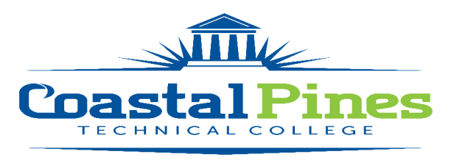

POSITION: Federal College Work Study (FCWS) Horticulture/Greenhouse Assistant

DEPARTMENT: Academic Affairs-Environmental Horticulture

STATUS: Part-time/Non-exempt LOCATION: Waycross

Education and/or Occupational Experience:
Possess a high school diploma, a GED, pass an approved ability to benefit test, or have been home-schooled. Also, FCWS student must be enrolled as a student and taking at least six credit hours at Coastal Pines Technical College in a technical certificate of credit, diploma, or associate degree program.
Minimum Qualifications:
- Be a United States citizen, permanent resident, or other reliable classification of non-citizen
- Have a valid Social Security number
- Make Satisfactory Academic Progress for Federal Student Aid Programs
- Meet the requirements of the Federal College Work Study Program
Key Competencies
- Excellent verbal communication skills and customer service skills
- Dependable and Trustworthy
- Ability to follow directions and complete assigned tasks
- Basic Computer operation skills
- Ability to Work in Greenhouse
- Ability to operate Power Equipment
- Ability to maintain and care for plants
- May be required to lift a maximum of 50 lbs.
- Ability to work outdoors, in the heat/cold
- Preferred that applicant has completed Introductory Horticulture courses or is enrolled in the Environmental Horticulture Program
Duties/Responsibilities
Federal College Work Study Students may work up to but no more than 20 hours per week.
This FCWS worker will be responsible for:
- Maintain and Clean Greenhouse
- Maintain, Clean, and Organize Headhouse/Shop areas
- Care for and Maintain plants (watering, fertilizing, transporting, propagating, etc.)
- Assist in Horticulture classroom
- Assist with Plant Sales, HORT Club functions, and recruitment periodically
- Other duties as required
Application Deadline: Until Filled Salary: $10/hour

Length of Employment: Work Study Contract will end on the final day of the semester

APPLICATION PROCESS:
Interested applicants should apply via CPTC ONLINE JOB CENTER. The letter of interest and resume along with copies of transcripts must be uploaded to the Job Center. A criminal background check and a driver’s motor history report will be
conducted prior to employment.

For additional information, contact Katrina D. Howard, Human Resources Coordinator at khoward@coastalpines.edu or
call 912-427-5876.

Coastal Pines Technical College (CPTC) does not discriminate on the basis of race, color, creed, national or ethnic origin, gender, religion, disability, age, political affiliation or belief, genetic information, veteran status, or citizenship status (except in those special circumstances permitted or mandated by law). The following persons have been designated to coordinate the College’s implementation of non-discrimination policies: Katrina Howard, Title IX Coordinator, Jesup Campus, 1777 West Cherry Street, Jesup, Georgia, khoward@coastalpines.edu , 912.427.5876; Cynthia Linder, Title IX Coordinator, Waycross Campus, 1701 Carswell Avenue, Waycross, Georgia, clinder@coastalpines.edu, 912.287.4098; Cathy Montgomery, ADA/Section 504 Coordinator, All Campuses, 3700 Glynco Pkwy, Brunswick, Georgia, 31525 cmontgomery@coastalpines.edu, 912.262.9995.

