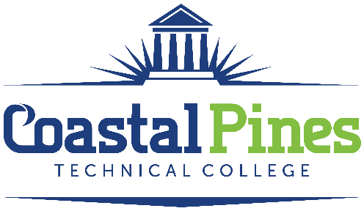

Position: Status:
Library Assistant – Part Time Part-time / Non-Exempt

Department: Academic Affairs Location: Jesup
Minimum Qualifications:
- High school diploma or equivalent and knowledge of library automation and computer applications.

Preferred Qualifications:
- Bachelor’s Degree from a nationally or regionally accredited college or university or
- An Associate’s Degree from a nationally or regionally accredited college or university with two years full-time experience working in a library setting.
- Previous library work experience.

JOB DESCRIPTION:
Under general supervision, provides circulation services for all library materials. Processes library acquisitions or assists in the acquisitions process. Assists in the promotion of library publicity projects. Assists in providing library orientations. Performs administrative/clerical duties and production functions. Assists library patrons in utilizing computers and software applications. Monitors the use of and maintains supplies for library.

JOB DUTIES and RESPONSIBILITIES:
- Assists patrons with the utilization of the library in a courteous and professional manner.
- Charges and discharges library materials and creates/updates patron records.
- Appropriately retrieves, opens, screens and/or distributes incoming mail in a timely manner.
- Reports any changes in magazine subscription requests, changes of address, and cancellations.
- Compiles regular and special statistical reports on users and circulation of library materials and the conditions of materials and equipment.
- Monitors supply needs on a regular basis.
- Introduces library patrons/staff/faculty to available applications and how to access them.
- Organizes shelves so that all materials remain in an orderly manner.
- Assists with providing orientation/instruction sessions as needed.
- Trains and supervises work study students.
- Participates in required staff development activities.
- Performs other duties as assigned by the Director of Library Services.

APPLICATION DEADLINE: Open until filled.

SALARY: $12.00 - $15.00 / hour. Commensurate with education and work experience.
Application Process: Open until filled. The interviewing process will begin immediately.

Application Process:
Interested applicants should apply via CPTC ONLINE JOB CENTER. The letter of interest and resume along with copies of transcripts and professional licenses must be uploaded to the Job Center. A criminal background check, reference checks and a driver’s motor history report will be processed prior to employment. Clinical site employees will be subject to a random drug testing pool. Official transcripts are required upon hire.

Coastal Pines Technical College (CPTC) does not discriminate on the basis of race, color, creed, national or ethnic origin, gender, religion, disability, age, political affiliation or belief, genetic information, veteran status, or citizenship status (except in those special circumstances permitted or mandated by law). The following persons have been designated to coordinate the College’s implementation of non-discrimination policies: Katrina Howard, Title IX Coordinator, Jesup Campus, 1777 West Cherry Street, Jesup, Georgia, khoward@coastalpines.edu , 912.427.5876; Brittaney Coleman, Title IX Coordinator, Waycross Campus, 1701 Carswell Avenue, Waycross, Georgia, bcoleman@coastalpines.edu , 912.287.4098; Cathy Montgomery, ADA/Section 504 Coordinator, All Campuses, 3700 Glynco Parkway, Brunswick, Georgia, cmontgomery@coastalpines.edu, 912.262.9995.

