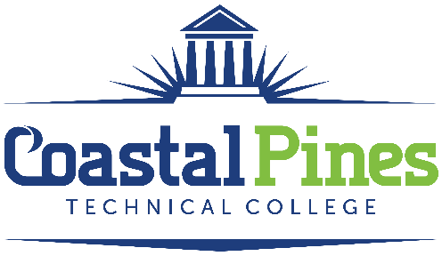

POSITION:
Library Assistant – Part Time / Non-Exempt

DUTIES:
Under general supervision, provides circulation services for all library materials. Processes library acquisitions or assists in the acquisitions process. Assists in the promotion of library publicity projects. Assists in providing library orientations. Performs administrative/clerical duties and production functions. Assists library patrons in utilizing computers and software applications. Monitors the use of and maintains supplies for library.

- Assists patrons with the utilization of the library in a courteous and professional manner.
- Charges and discharges library materials and creates/updates patron records.
- Appropriately retrieves, opens, screens and/or distributes incoming mail in a timely manner.
- Reports any changes in magazine subscription requests, changes of address, and cancellations.
- Compiles regular and special statistical reports on users and circulation of library materials and the conditions of materials and equipment.
- Monitors supply needs on a regular basis.
- Introduces library patrons/staff/faculty to available applications and how to access them.
- Organizes shelves so that all materials remain in an orderly manner.
- Assists with providing orientation/instruction sessions as needed.
- Trains and supervises work study students.
- Participates in required staff development activities.
- Performs other duties as assigned by the Director of Library Services.

EDUCATION:
High school diploma or equivalent

MINIMUM QUALIFICATIONS:
Knowledge of library automation and computer applications.

PREFERRED QUALIFICATIONS:
- Bachelor’s Degree from a nationally or regionally accredited college or university or
- An Associate’s Degree from a nationally or regionally accredited college or university with two years full-time experience working in a library setting.
- Previous library work experience.

APPLICATION DEADLINE:
Open until filled.

SALARY:
$12.00 - $16.00 / hour. Commensurate with education and work experience.

APPLICATION PROCESS:
Interested applicants should apply via CPTC ONLINE JOB CENTER by completing the online application form. The letter of interest and resume along with additional documentation specific to the position must uploaded to the Job Center. Incomplete application packages cannot be considered for an interview and will not be forwarded to the hiring supervisor. A criminal background check and a driver’s motor history report will be conducted prior to employment.
Equal Opportunity Statement
Coastal Pines Technical College (CPTC) does not discriminate on the basis of an individual’s age, color, disability, genetic information, national origin, race, religion, sex, or veteran status (“protected status”). The following persons have been designated to coordinate the College’s implementation of non-discrimination policies: Brandie McLaughlin, Title IX Coordinator, Jesup Campus, 1777 West Cherry Street, Jesup, Georgia, HR@coastalpines.edu 912.427.5876; Emily Harris, Title IX Coordinator, Waycross Campus, 1701 Carswell Avenue, Waycross, Georgia HR@coastalpines.edu 912.287.4098; titleix@coastalpines.edu ADA/Section 504 Coordinator, ada@coastalpines.edu ; All Campuses, 1777 West Cherry Street, Jesup, Georgia.

