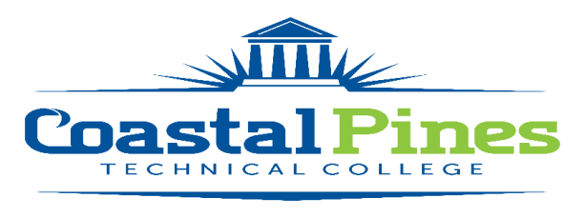

POSITION: Speech Instructor – 10-month Dual Enrolled STATUS: Full-time, Exempt Position

LOCATION: Area high schools

DUTIES:
Under general supervision demonstrates the use of appropriate teaching techniques. Demonstrates the use of appropriate testing and grading procedures, including proper maintenance of grade books and any other appropriate record-keeping requirements. Primary appointment is traveling to various area high schools or CPTC College Sites to teach through the Dual Enrollment Program. The majority of classes will be scheduled during the school day.

MINIMUM QUALIFICATIONS:
- Master’s degree in Speech/Communications or Master’s degree and 18 graduate semester hours in Speech/Communications from a regionally accredited institution.

PREFERRED QUALIFICATIONS:
- Post -Secondary teaching experience
- Dual Enrollment or high school teaching experience

TECHNICAL COMPETENCIES:
- Ability to develop and evaluate lesson plans
- Ability to work flexible hours, including evening hours
- Ability to juggle multiple and competing priorities
- Ability to teach at any campus where classes are taught
- Ability to work well in the classroom and supervise students in laboratory settings
- Ability to direct and assess students’ progress in achieving required competencies
- Ability to handle administrative responsibilities related to teaching of courses, data collection and reporting for licensing agencies, accreditation agencies and/or College

APPLICATION DEADLINE: Open until filled.

Salary/Benefits:
$40k annually. Salary is in accordance with guidelines established by the Technical College System of Georgia. This is a full-time/10 month position paid over 12 months with a State of Georgia benefits package.

APPLICATION PROCESS:
Interested applicants should apply via CPTC’s Online Job Center at CPTC ONLINE JOB CENTER. A letter of interest with resume and copies of transcripts must be uploaded with the application. A criminal background check, reference checks and a driver’s motor history report will be conducted prior to employment. Official transcripts are required upon hire.

For additional information, contact Katrina D. Howard, Human Resources Director at khoward@coastalpines.edu or call (912)427-5876.

Coastal Pines Technical College (CPTC) does not discriminate on the basis of race, color, creed, national or ethnic origin, gender, religion, disability, age, political affiliation or belief, genetic information, veteran status, or citizenship status (except in those special circumstances permitted or mandated by law). The following persons have been designated to coordinate the College’s implementation of non-discrimination policies: Katrina Howard, Title IX Coordinator, Jesup Campus, 1777 West Cherry Street, Jesup, Georgia, 912.427.5876; Brittaney Coleman, Title IX Coordinator, Waycross Campus, 1701 Carswell Avenue, Waycross, Georgia, 912.287.4098; Cathy Montgomery, ADA/Section 504 Coordinator, All Campuses, 3700 Glynco Pkwy, Brunswick, Georgia, 912.262.9995.

