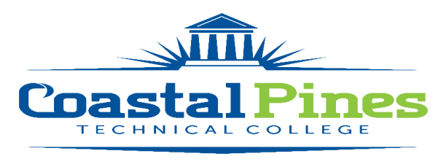

POSITION: STATUS: Full-time/Non-Exempt
Technical Support Specialist

LOCATION:
All

SALARY:
$35,000 annually with degree. This is a full-time position, including a state of Georgia benefits package.

DUTIES:
Under general supervision, installs and provides technical support and problem resolution to complex PC- and server-based hardware and software used at any site of the College. The Technical Support Specialist assists with the installation, termination and testing of fiber and copper cabling, maintenance of PCs and servers, and other technology applications. Other duties include installing and upgrading operating systems and application software, troubleshooting problems and providing courteous customer assistance.

MINIMUM/PREFERRED QUALIFICATIONS:
Associate’s degree *and* three (3) years of work-related experience.
Note: Experience may substitute for the degree on a year-for-year basis *or* obtain degree within two to three terms after hire date. A memorandum of understanding will be initiated for employee to complete the degree requirement.

Training and experience leading to demonstrated competencies to provide software/hardware support to multi-user computer network systems and to evaluate customer requests and identify current system requirements to recommend solutions.
- Excellent oral communication, written communication, time-management and organizational skills.
- Positive, effective and professional customer service and relation skills with staff, students,
community members and colleagues whose computer skill-levels vary widely.
- Ability to work with a minimum of supervision, and exhibit adaptability and flexibility.
- Pro-active attitude in anticipating, pre-empting, finding and solving problems.
- Familiarity with Win 10 environments, wiring, wireless technologies, and Internet
- Ability to lift and carry 50 pounds safely.

JOB DUTIES/RESPONSIBILITIES:

- Installs computers and printers in classrooms and labs as well as faculty and staff work areas.

- Installs, configures and upgrades hardware, operating system software and application software.

- Assists with the installation, termination and testing of fiber and copper cabling.

- Assists with the installation, management and monitoring of server operating systems and services.

- Responds to Electronic Helpdesk requests.

- Performs timely escalation of pending support-related issues to various departments for further analysis and resolution.

- Utilizes a variety of tools, techniques and procedures to resolve problems.

- Maintains software and hardware inventories, as necessary.

- Pro-actively anticipates, pre-empts, diagnoses and solves hardware, network, and software problems.

- Assists in the yearly planning and budgeting process for information technology by making informed recommendations.

- Provides technical support for College staff and IT resources at all sites. This may be accomplished via telephone, remote assistance, or physical presence as deemed appropriate.

- Performs all other duties as assigned by the Director of Information Technology, the Executive Director of Information Technology, or the College President.

APPLICATION DEADLINE:
Open until filled. Initial screening/interviewing will begin as needed.

APPLICATION PROCESS:
Interested applicants should apply via CPTC’s Online Job Center at CPTC ONLINE JOB CENTER. A letter of interest with resume and copies of transcripts must be uploaded with the application. A criminal background check and a driver’s motor history report will be conducted prior to employment. Official transcripts are required upon hire.
For additional information, contact Emily Harris, Human Resources Coordinator at eharris@coastalpines.edu, or call 912.287-4098.

Coastal Pines Technical College (CPTC) does not discriminate on the basis of race, color, creed, national or ethnic origin, gender, religion, disability, age, political affiliation or belief, genetic information, veteran status, or citizenship status (except in those special circumstances permitted or mandated by law). The following persons have been designated to coordinate the College’s implementation of non-discrimination policies: Katrina Howard, Title IX Coordinator, Jesup Campus, 1777 West Cherry Street, Jesup, Georgia, khoward@coastalpines.edu , 912.427.5876; Emily Harris, Title IX Coordinator, Waycross Campus, 1701 Carswell Avenue, Waycross, Georgia,eharris@coastalpines.edu , 912.287.4098; Katie Rutland, ADA/Section 504 Coordinator, All Campuses, 3700 Glynco Parkway, Brunswick, Georgia, krutland@coastalpines.edu, 912.262.9995.

