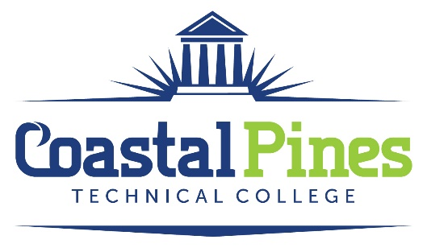

POSITION: Economics Instructor – Adjunct

DUTIES:
Successful applicants will be responsible for overall classroom instruction for degree level courses to include preparing lesson plans, maintaining department guidelines and standards, evaluating students by assigning grades and interact with high school coordinators, faculty and deans. Position begins May 2023

EDUCATION:
A minimum of a master’s degree in Economics or a master’s degree with 18+ graduate semester hours in Economics from an accredited institution
MINIMUM QUALIFICATIONS:
A minimum of a master’s degree in Economics or a master’s degree with 18+ graduate semester hours in Economics from an accredited institution. Excellent written and verbal communication skills.
PREFERRED QUALIFICATIONS:
Teaching experience in secondary and/or postsecondary educational institution.

APPLICATION DEADLINE:
Open until filled.

SALARY/BENEFITS:
Salary will be determined in accordance with guidelines established by the Technical College System of Georgia. Benefits include the State of Georgia Flexible Benefits Program, State of Georgia holidays, and annual/sick leave.

APPLICATION PROCESS:
Interested applicants should apply via CPTC ONLINE JOB CENTER by completing the online application form. The letter of interest and resume along with additional documentation specific to the position must uploaded to the Job Center. Incomplete application packages cannot be considered for an interview and will not be forwarded to the hiring supervisor. A criminal background check and a driver’s motor history report will be conducted prior to employment.

Equal Opportunity Statement
Coastal Pines Technical College (CPTC) does not discriminate on the basis of race, color, creed, national or ethnic origin, gender, religion, disability, age, political affiliation or belief, genetic information, veteran status, or citizenship status (except in those special circumstances permitted or mandated by law). The following persons have been designated to coordinate the College’s implementation of non-discrimination policies: Katrina Howard, Title IX Coordinator, Jesup Campus, 1777 West Cherry Street, Jesup, Georgia, khoward@coastalpines.edu , 912.427.5876; Emily Harris, Title IX Coordinator, Waycross Campus, 1701 Carswell Avenue, Waycross, Georgia, eharris@coastalpines.edu, ; Katie Rutland, ADA/Section 504 Coordinator & Title IX Coordinator for all students, All Campuses 1777 West Cherry Street, Jesup, Georgia, krutland@coastalpines.edu, 912.424-3645

