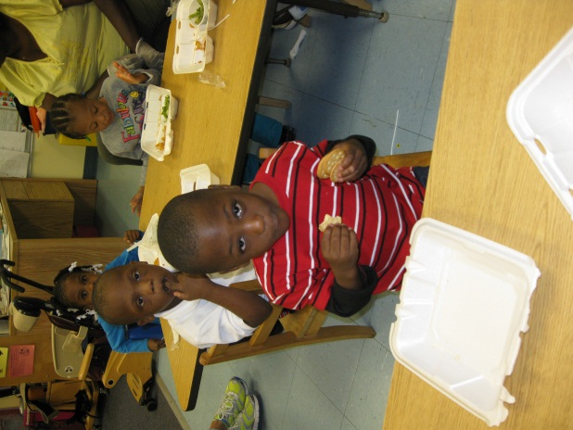
We are looking for volunteers to assist us in our Preschool at UCP of Broward County, Inc. We are an integrated preschool program for the Department of Education and community children who receive individualized instruction and development in preacademics, fine and gross motor skills, speech and language, socialization and daily living skills. Our program provides increased opportunities for children with physical impairments to learn from observing and interacting with their peers. It enables the children to be models for each other, helps language, motor and social skill development and fosters positive self- esteem. The goal is to help each child reach his or her full potential and become as independent as possible. The school is open from 9 am to 2 pm, Monday through Friday and our children range in age from one to five years. Level II clearance is required.
We have a need for assistance during our lunch program, play time and during field trips. If you are interested please contact Human Resources at 954-315-4044 or 954-315-4042.

