**Miami Cerebral Palsy Residential Services, Inc.**

***Intermediate Care Facility for the Developmentally Disabled***

***A Private, Not for Profit Agency Established in 1984***

**2200 SW 107th Avenue • Miami, Florida 33172 • (305) 599-0899 • Fax: (305) 599-2721**

**mcprs.org**

Marta E. Morin Migdalia Santiago

Chief Operating Officer Associate Director

**Administrative Assistant**

**Reports To:** Administrator

**Positions Supervised:** None

**Number of available positions**: 1

**Location:** 14400 SW 32nd Street, Miami, Fl 33175

**JOB SUMMARY:**

The Administrative Assistant performs a variety of highly responsible office management work requiring knowledge of a special field. Duties will vary and must be carried out with a high level of confidentiality, discretion, professionalism and independent judgment. Must show integrity and responsibility; promote justice, fairness and equity. Be respectful, assist in developing and maintaining relationships among team members, staff, individuals, parents, and community. Act as a professional liaison between facility administrator and staff, vendors, outside agencies, community, families and residents to include: redirecting, clarifying, advising, coaching and mentoring. Keeps administrator informed as necessary. Interpersonal and human relationship skills are required for a successful administrative assistant

**REQUIRED QUALIFICATIONS:**

* Minimum of high school diploma or equivalent with supplemental related college coursework preferred. Secretarial/Business course of study, business School, or College, or equivalent experience (i.e., on the job training supported by relevant course work).

* Three years of office management and secretarial work required. Any equivalent combination of training and experience which demonstrates the knowledge, skills and ability to perform the job duties.
* Candidate will be expected to present with the highest level of professional communication, organization, dedication and confidentiality.
* Be able to perform many tasks at once, and handle responsibilities that can change on a daily basis.

* Must be orderly, adaptable, professional, and courteous, motivated and work well on their own or as a member of a team.
* PC literate in word, excel outlook, power point. Should possess strong typing skills, and be well-versed in other areas of office work, as must enter data and keep employee records via [computers](http://www.ehow.com/computers/).
* Able to convey important information to co-workers, superiors and [job](http://www.ehow.com/about_6560254_hr-clerk-job-description.html) candidates.
* Ability to represent agency in a consistent professional manner to include professional and conservative dress attire.
* Ability to maintain the highly confidential nature of all related work.
* Demonstrated integrity and honesty.
* Demonstrated commitment to provide services to the developmentally disabled population.
* Self-starting personality with an even disposition.
* Strong written and verbal communication skills. High proficiency in speaking, reading and writing English.
* Excellent organizational skills and effectiveness at meeting deadlines.
* Strong computers skills ( Microsoft Office, Outlook )
* Ability to work under pressure & handle multiple tasks simultaneously and set priorities. Great follow up skills.
* Independent personality with an ability to work in a team setting. Excellent customer service attitude.
* Able to consistently demonstrate independent & sound judgment in representing the facility, administrator & application of agency policy & procedures. Ability to set priorities.
* Ability to represent agency in a consistent professional manner to include professional and conservative dress attire.
* Provide a professional image at all times through appearance and dress
* Ability to communicate, interact and work effectively and cooperatively with all people including those from diverse ethnic and educational backgrounds
* Ability to recognize the importance of safety in the workplace, follow safety rules, practice safe work habits, utilize appropriate safety equipment and report unsafe conditions to the appropriate personnel staff.
* Diligent, detail oriented and ability to prioritize work.
* Must have ability to communicate effectively and in a timely manner with Administrator facility, residential home managers and staff.
* Must have ability to accept constructive criticism.

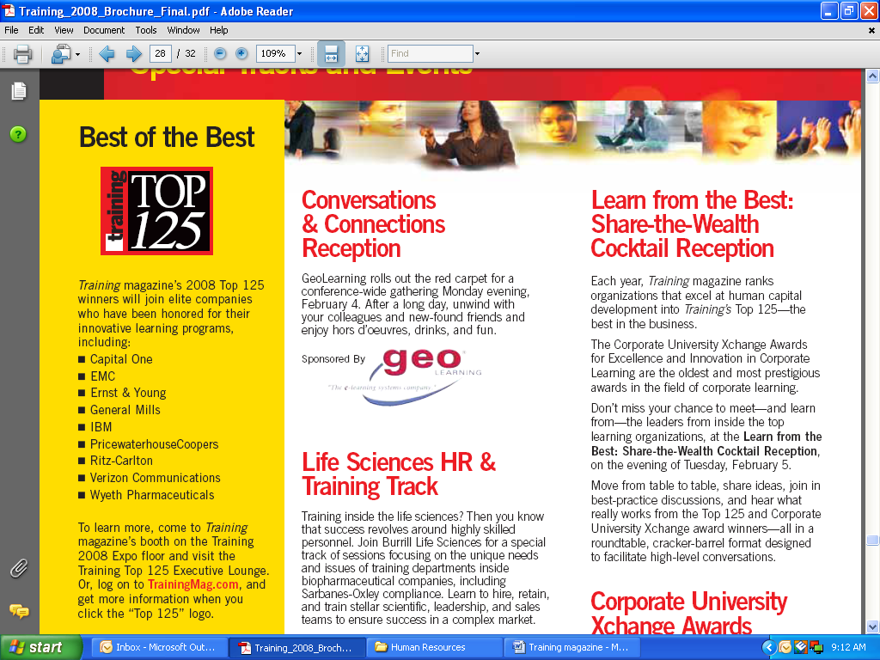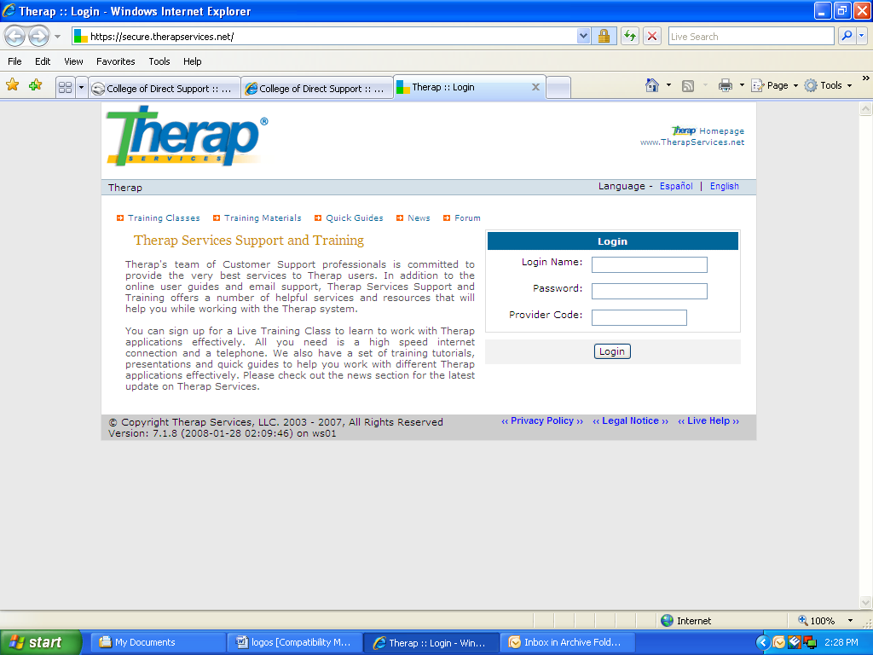

**JOB DUTIES AND RESPONSIBILITIES:**

* Act as an active liaison between facility administrator and staff, vendors, outside agencies, community, families and residents to include: redirecting, clarifying, advising, coaching and mentoring. Keeps administrator informed as necessary.
* Serves as a frontline human resources representative providing guidance to staff at the facility in terms of transfers, requisitions, vacancies, employee time record/payroll, physical examinations, performance evaluations and other HR activities.
* Follows-up with administrator & human resources department on any problems or past due dates.
* Keeps up to date on all employee training requirements. Scheduling staff in coordination with staff development director to attend mandatory training such as: Pre-service, Active treatment, Physical Management.
* Responsible for implementing, initiating & maintaining an organized & easy to follow record-keeping & filing systems including individual’s central files.
* Responsible for all office management for the facility to include : coordination, authorization of all office equipment use, office supplies, facility property management inventory, etc
* Responsible for handling facility petty cash, reconciling, processing receipts and reimbursement & emergency funds.
* Responsible for proof-reading all documents for content appropriateness, accuracy, typing, collating, filing, copying, distributing & mailing of all work for administrator & other facility personnel (letters, memorandums, programs, projects, meetings minutes, policies & procedures forms, briefings & postings & other work as needed).
* Screens, re-directs & handles in-coming calls.
* Responsible for facility property management inventory.
* Able to convey important information to co-workers, superiors and [job](http://www.ehow.com/about_6560254_hr-clerk-job-description.html) candidates.
* Ability to take accurate and efficient notes.
* Creative ability.
* Ability to work independently.
* Prepares facility records for scanning, scans records & actively participates in the development of systems, & ensures proper implementation.

**ESSENTIAL JOB FUNCTIONS:**

The physical demands, work environment factors and mental functions described below are representative of those that must be met by an employee to successfully perform essential functions of this job.

**This position has the following physical requirements:**

* Lifting and carrying a minimum of 20lbs from the floor up to waist, lift from floor to overhead, push/pull minimum of 20lbs, bending, squatting, twisting, reaching, climbing, standing, walking, use of hands and kneeling for tasks that may be required to do.
* Functional gross and fine motor skills.
* Functional dexterity needed in all aspects of body movements.

Reasonable accommodations may be made to enable individuals with disabilities to perform the essential functions*.*

**WORKING CONDITIONS:**

* All job duties will be performed at the Intermediate Care Facilities.

This position may be required and exposed to the following:

* To work flexible schedules.

**All applicants/employees must comply with Miami Cerebral Palsy Residential Services, Inc. Drug Free Workplace Policy and Background Screening Requirements**.

**STATEMENT OF UNDERSTANDING:**

I have received, read and understand and will adhere to the above position job summary and essential job function requirements. I confirm that I meet the requirements.

___________________________________ ________________

Applicant/Employee’s Printed Name Date

___________________________________ ________________

Applicant/Employee’s Signature Date

